CAVCO SALES
Office: 620-767-7273 Mobile: 785-466-0189 Fax: 620-767-5303

Visit our Website & View All Our Machine Pictures: www.cavcosales.com

E-Mail Us: cavco@tctelco.net
Visit Our E-Bay Store At: http://stores.ebay.com/e-cavco

November 10, 2022

Pictures Are Available On-Line at www.cavcosales.com

We Are Distributors For The Following Manufacturers

Goodson Products - Regis Manufacturing – Winona Van Norman, Silver Seal - Kwik Way Boring Bar Repair Parts & Supplies – Van Norman Flywheel Grinders Peterson & Van Norman Boring Bar Repair Parts

Used Equipment List

Crankshaft Equipment

CA2233 Crankshaft Grinder Storm Vulcan Model 14, 230v, 3ph. 4,790.00
Comes With: 4-Hubs & Stones, Steady Rest, Stone Dresser, Arnold Gauge Assembly
w/ 3”-5” Caliper And Wheel Balancer.

CA2247 Crankshaft Balancer Stewart Warner Model 2000, 115v. 5,395.00
Comes With: Tri Bearing Parts For Drive Line Balancing, V-8 Bob-Weights, Extra
Stanchion Bearings, Rod Weighing Fixture & Scale.

CA2251 ABS Milling Mounted A Table Mounted Bench Mill Using R-8 Collets System Designed Around Drilling 3,275.00
Bench Mill & Milling Crankshafts When Using The Stewart Warner Balancer Without The Drill
Function. A Slide Way And Platform Makes The Weight Removal Process Extremely
Easy And Functional.

CA-HUBS Crankshaft Wheel We Have A Varity Of Used Crankshaft Grinding Wheel Hubs In Stock. Sorry But 150.00 – 250.00
Centers We Can’t Identify Many Of Them But We Can Measure And Send Pictures.

CA2265 Wheel Balancing Stand Precision Wheel Balancing Stand, 48” Diameter Capacity. 685.00
Comes With: New Paint and Adjustable Rails For Width.

CA2272 Radius Dresser Used For Berco 260 Crankshaft Grinder. 965.00

Connecting Rod Equipment & Tooling

CA2224 Mandrel Set For Sunnen Piston Pin Honing Mandrels, In Good Condition. Used for Honing Pistons 595.00
Grooved Piston With Pin Bore Grooves.
Comes With: SYY-927, SYY-973, SYY-989, SYY-1094. All With Used Stones.

CA2187 Pin Boring Setting Sunnen Tobin Arp Tool Setting Fixture Model CM. Used to accurately Set Boring 725.00
Fixture Tools For Boring Operations.

CA1942 Piston Pin Press PMW Open Throat 10 Ton Pin Press, Air/Hydraulic. 1,350.00
Comes With: Press Plate & Air/Hydraulic Foot Operated Pump Unit.

CA2200 Rod Bend & Twist Sunnen Model TN-111. 495.00
Checking Fixture Comes With: TN-46A & TN-50A Checking Fixtures.

CA2218 Rod Bend & Twist Sunnen Model TN-111. 495.00
Checking Fixture Comes With: TN-46A & TN-50A Checking Fixtures.

CA???? Rod Bend & Twist Sunnen Model TN-111. 495.00
Checking Fixture Comes With: TN-46A & TN-50A Checking Fixtures.

CD2262 Connecting Rod Sunnen Model CRH-50, 115v (Red Unit) 965.00
Heater Comes With: Wrist Pin Pushing Tool And New Paint.

CA2208 Rod & Cap Grinder Sunnen Model CRG-770, Rod & Main Cap Grinder115v. 2,150.00
Comes With: Diamond Dresser, Dust Catching Container & New Paint.

CA2248 Rod & Cap Grinder Sunnen Model CRG-500, 115v. 675.00
Comes With: Good Stone, Tested & Ready To Work.

CD2263 Rod & Cap Grinder Sunnen Model CRG-780, Rod & Main Cap Grinder115v. 2,275.00
Comes With: Diamond Dresser, Dust Catching Container & New Paint.

CA2250 Sunnen Precision Rod Sunnen Model AG-300. 975.00
Sizing Gauge Comes With: Gauge Mounting Bracket, Standard Points, Centralizer Rings,
Standard Tools And Metal Storage Box.

CA2304 Sunnen Precision Rod Sunnen Model AG-300. 995.00
Sizing Gauge Comes With: Gauge Mounting Bracket, Standard Points, Centralizer Rings,
Standard Tools And Metal Storage Box.

CA2003 Rod & Pin Hone Sunnen Model LBN, 115v. Dry Bench Top Machine W/ New Paint And Tested. 575.00

CA2069 Rod & Pin Hone Sunnen 2-Speed Model LBA-650, 115v. 895.00
Comes With: Mounted On Wood Storage Cabinet, SL Mandrel Set (.720” – 1.200”),
Coolant Pump & Wrist Pin Vise.

CA2245 Rod & Pin Hone Sunnen 2-Speed Model LBA-666, 115v. 1,175.00
Comes With: Mounted On Wood Storage Cabinet, Flow Over Oil System, Double
Torque Bar For Rod Work, Mounted On Storage Cabinet.

CA2199 Rod & Pin Hone Sunnen 2-Speed Model LBA-888, 115v. 1,650.00
Comes With: Cast Iron Base Machine, Electric Oil Pump, New Paint & Ready To
Work.

CA2211 Horizontal Honing Sunnen Model MBB-1660, 115v. 2,450.00
Machine Comes With: Twin Torque Bar, 12-Speed Selections, Small Mandrel Fine Pressure
Adjustment And Adjustable Coolant Lines.

CA2299 Rod & Pin Hone Sunnen Floor Model Machine Model LBB-1699, 115v. In Great Condition. 2,850.00
Comes With: Twin Torque Bar, 6-Speed Combinations And Spindle Feed Indicator.

Rod Honing Mandrels We Stock A Large Selection Of Used Connecting Rod & Industrial Honing Mandrels!

Cylinder Head Equipment & Tooling

CA2256 Valve Guide & Seat Winona Van Norman Model PH-2000L, Large Base Machine, 230v, 3ph. 6,950.00
Machine Comes With: Spindle/Valve Guide Level, .375 Leveling Pilots, Spot Facer & Pilots,
11/32 & 3/8 Core Drills/Reamers, Valve Seat Ring Pocket Cutters With Driver, Valve
Seat Driver Set, Valve Seat Centering Cone & Pilot Set & Sunnen Style SGM Seat
Cutter Set Complete, (2-Bodies, 4-Tip Holders, Wrenches, Setting Fixture & Lift Off
Springs

CA2301 Valve Guide Bore Sunnen Model P310, Like New Condition 1,540.00
Gauge Comes With: .312”, .344” & .373” Probes, All Standard Tools And Metal Box.

CA2303 Valve Guide Honing Sunnen Model P-190 Kit 735.00
Set Comes With: P-180 Hone Head, Stones, Mandrels, Truing Sleeves And Adaptors For
5/16”, 11/32”, 3/8” & 7/16” Valve Guides.Extra L10-J47 & L12-J47 Abrasives and an
Extra PK-12 Adaptor.

CA2276 Cylinder Head Peterson/Kansas Instruments Model SRA-30. 4,850.00
Assembly Bench Comes With: Fully Reconditioned Unit Mounted On A Storage Cabinet.

CA2257 Sunnen 3-Angle Tool Model Series II, 115v. 1,175.00
Sharpener Comes With: 360 & 600 Grit Diamond Wheels, And Sunnen’s VSC Tool Sharpening Jig

CA2188 Cylinder Head Porting/ Kwik Way Manufactured These Rollover Stands. Dual Head Capacity. 675.00
Rollover Fixture

CA2234 Complete Cylinder A Complete Head Clamping Fixture From A Serdi 100. 695.00
Head Clamping Fixture Comes With: Rails, Post Clamps And Hardware.

CA2072 Heated Cylinder Head Manufactured By Donelly Engineering. Uses Heated Water Circulated Through The 1,250.00
Pressure Tester Head To Perform The Test Heated, 220v, 3ph. 43” Capacity.
Comes With: A large Selection Of Custom Testing Plates And Block Off Adaptors.

CA1732 Valve Refacer Cabinet Sioux Model 644. Very Well Made & Sturdy. 465.00
Comes With: Valve Holder Wings

CA2081 Valve Refacer Cabinet Black & Decker? Well Made, Sturdy And On Wheels. 355.00

CA1788 Valve Seat Grinding KO Lee Model P302BB, 115v. 745.00
Set Comes With: 1-Stone Holders, Electric Driver, Stone Dresser, 6-Collapsing Pilots,
Metal Storage Box And 25 Various Grinding Stones.

CA2167 Valve Seat Grinding Black & Decker, 115v. 525.00
Set Comes With: 2-Stone Holders, Electric Driver, Stone Dresser, 4-Groove Top Pilots,
Pilot Installer/Removal Tool, Metal Storage Box And Various Grinding Stones.

CA2174 Valve Seat Grinding Sioux Model 1725E, 115v. Hex Drive. 875.00
Set Comes With: Angle Electric Driver, A Good Selection Of Stones & Pilots, 2 Wheel
Holders, Stone Dresser And Metal Storage Box.

CA2236 Valve Seat Grinding Kwik Way Model SGH, 115v. 1,475.00
Set Comes With: 3-Stone Holders, Angle Electric Driver, 24-Taper Pilots, 4-Expandable
Pilots, 36-Various Stones, Heavy Duty Stone Dresser, Pilot Installer/Remover & Steel
Storage Box. In Very Good Condition.

CA2191 Mira Tool Sharpening Peterson Model TS-89, 115v. Currently Set Up For Mira Formtools But Can Be Modified 395.00
Fixture For Use With Serdi Style Inserts.

Surfacing Equipment

CD2295 BHJ Block Tru Complete Basic Kit and 5 different sets of Mains Rings. 675.00

CA2235 Head & Block Mill Berco Model STCA-900, 230v, 3ph. 7,885.00
Comes With: Universal Head & Block Clamping Fixture, 11” Milling Cutter Plate, 38”
Table Travel With 2 Speeds, Comes With Power Downfeed and R-8 Capacity For Some
Boring Applications.

CA2068 Head & Manifold Dry Van Norman Model 555, 230v, 3ph. 550.00
Grinder Comes With: 10” Stone.

CA2229 Platen Surface Grinder Peterson/KI Model PG1400, 230v, 3ph. 6,900.00
Belt Surfacer Comes With: New 40 Grit Belt, Grinding Coolant, New Paint, Upgraded Coolant Lines
& Electrical Switches. Working Capacity 14” x 34”.

CA2280 Platen Surface Grinder Peterson/Kansas Instruments Model RG-1203, 230v, 3ph. 4,650.00
Comes With: Foot Pedal Operation, New 40 & 80 Grit Surfacing Belts & New Paint.

CB2049 Flywheel Grinder Peterson Model FG-596, 230v, 3ph. 3,475.00
Comes With: Standard Tooling Package, 6” CBN Wheel & Grinding Coolant.

Block Boring & Honing Equipment

CA2300 Kwik Way FW Tool A Fairly Complete “FW” Tool Kit In Very Good Condition. Shows Very Little Use. 1,250.00
Kit Complete

CA2214 Cylinder Bore Gauge Sunnen Model GA2121, 2.00” – 6.00” Capacity. 765.00
Comes With: Standard Tools, Extra 4” Extension And Storage Case.

CA2227 Cylinder Bore Gauge Sunnen Model GA2121, 2.00” – 6.00” Capacity. 765.00
Comes With: Standard Tools, Extra 4” Extension And Storage Case.

CA2305 Cylinder Bore Gauge Sunnen Model GA2121, 2.00” – 6.00” Capacity. 795.00
Comes With: Standard Tools, Extra 4” Extension And Storage Case.

CA2249 Sunnen Bore Gauge Sunnen Model CF-1000. 1,095.00
Setting Fixture Comes With: 2.0” – 6.0” Setting Standards, All Service Tools And Metal Storage Box.

CA2198 100” Line Boring Berco Model BC-5, 230v, 3ph. 18,450.00
Machine Comes With: 4-Complete Bar Kits, Setting Fixture w/ New Indicator, 2-Sets Parallels,
Thrust Cutter Attachment And New Paint

CA2242 Portable Line Boring Kwik Way Model LBM, 70” Unit. A very Complete Kit In A Metal Storage Box. 4,850.00
Outfit

CA2400 New Aftermarket Line 10RY-1800 2,375.00 Hone Mandrels 10RY-2100 2,475.00
10RY-2400 2,575.00 10RY-2700 2,675.00
10RY-3000 2,775.00

CA2150 Sunnen Line Hone 15RY-4500 3,550.00
Mandrel Comes With: New Stones & Good Guide Shoes.

CA2076 Universal Diesel Berco Designed Clamping Fixture For Boring Mill Applications. Pt # AOO.69650 1,650.00
V-Block Boring Fixture A Quick Clamping Universal Fixture Used For Larger Diesel V-Blocks.

CA2230 Small Engine Boring Kwik Way Model 1291. 1,2655.00
Fixture Comes With: Deck Parallels And Adjustable Lower Clamping System

CA2092 Portable Boring Bar Kwik Way Model FN, 115v. In Process
Comes With: Standard Boring Tools And Clamp Tooling. (In Process)

CA2087 Cylinder Boring Rottler Model FA2AB, 230v, 3ph. In Process
Fixture Comes With: 2 Sets Parallels, Standard Production Boring Head, 45 Degree Cradle,
& Standard Boring Tools.

CA2089 Cylinder Boring Berco Model ACP-151, 230v, 3ph. In Process
Fixture Comes With: 2-Sets Parallels, Standard Boring Head, 2-Sets Centering Fingers,
45 Degree Block Cradle, New Paint And Standard Tooling.

Cleaning Equipment

CA2215 Glass Bead Blasting Large Capacity Glass Bead Cabinet, 115v. Work Envelope 36” x 48” x 36” 4,750.00
Cabinet Comes With: Large Capacity/Multi-Bag Dust Collector, 25CFM Gun, Foot Pedal
Operation & New Gloves.

CD2293 Glass bead Cabinet A Good Used Trin-Mac Glass Bead Cabinet, Model 3, 115v. 24” x 36” Capacity. 825.00
Comes With: New 25CFM Gun & Carbide Nozzle, New Dust Collection Hose, New
Window Glass And Door Safety Switch.

CA2219 Glass Bead Cabinet A Twin Feed Cyclonic Bead Reclaimer For Glass Bead Cabinets. Allows for Single Or 625.00
Reclaimer Unit Dual Gun Operation. 1/2HP, 120V Blower Motor. Intake Size is 5” and Discharge Size
Is 4”. Can Be Used With A Dust Bag On The Discharge.

CA2113 Airless Shot Blaster Steel-A-Brator Head & Manifold Airless Blaster, 230v, 1ph. 3,870.00 Comes With: Spring Loaded Bars For Parts Positioning, Dust Collector, Mesh Style
Parts Basket And 30.5” x 11” Capacity.

CA2298 BK-17 Oven Transfer This allows a hot load to be moved to the next location without waiting until totally cool.
Cart

CA2240 Spray Washer Insta-Clean Top Load Spray Washer Model IC-4, 230v, 1ph. 3,150.00
Comes With: 2HP Pump, Castors Wheel Mounted, Electric Heat & New Paint.
Work Capacity: 29”H x 25”Diameter.

CA2241 Spray Washer Hotsy Top Load Spray Washer, 230v, 1Ph, Electric Heat 2,750.00.
Comes With: 1.5HP Pump, Castor Wheel Mounted And Electric Heat.
Work Capacity: 21”H x 19” Diameter.

CA2252 3HP Replacement Gusher 3HP Pump/Motor Assembly, 230v, 3ph. 575.00
Spray Washer Pump Comes With: 14.5” Stem Length, Complete Pump & Impeller Assembly. Tested And
Ready To Work.

CA2253 7.5 HP Replacement Gusher 7.5HP Pump/Motor Assembly, 230v, 3ph. 645.00
Spray Washer Pump Comes With: 14” Stem Length, Complete Pump & Impeller Assembly. Tested And
Ready To Work.

CA2254 7.5 HP Replacement Gusher 7.5HP Pump/Motor Assembly, 230v, 3ph. 645.00
Spray Washer Pump Comes With: 15.5” Stem Length, Complete Pump & Impeller Assembly. Tested And
Ready To Work.

CA2217 200 Gallon Hot Tank Peterson/Kansas Instruments Model 200, Electric Heat, 230v, 3ph. 200 Gallon Capacity. 3,950.00
Comes With: Aggressive Impeller Agitation, 2-24” x 22” Lift Baskets And 2” Drain
Valve And Full Insulation. Work Capacity 29.5” x 48” x 25” Depth Above Floor Grate.

CS1026 Solvent Tank Clean-Master, Large Solvent Parts Washing Tank, Model 90, 45 Gallon Capacity, 115v. 425.00 Comes With: Parts Cleaning Shelf and Castors For easy Positioning. Nice Looking Piece.

CA2114 Solvent Tank Free Standing Solvent Parts Washer, 115v. 165.00 Comes With: Decent Small Unit.

CO1663 Shot Tumbler Geoff Belt Type, 230v, 3ph. 1,390.00

Miscellaneous

CD2297 15HP Rotary Phase GWN Model DIGI254, 15HP 1,590.00
Converter Comes With: Capacitor Start And Capacitor Run. Mounted On HD Steel Stand.

CA2220 Vertical/Horizontal Grizzly Model G3617, 110v or 220v, 1ph. 4,650.00
Milling Machine Comes With: Separate Motors For Vertical/Horizontal Operation, Mill Vise, X-Axis
Power Feed, T-Nut Clamp Kit, Collet Set And Standard Wrenches.

CA2221 Small Engine Lathe Import 12” x 36” Lathe, 220v, 1ph. 2,150.00
Comes With: 3-Jaw, 4-Jaw Chucks, Faceplate, #3MT Tailstock, Live Center And A
Selection Of Tools.

CA2306 Smithy Combination Smithy Model Granit 1340, 115v. In Very Nice Condition. 4,650.00
Mill/Lathe/Drill Comes With: A Good Assortment Of Tooling. Uses R-8 Collets.

CA2261 Piston Knurler Perfect Circle Model “Knurlizer”. 895.00
Comes With: Preset Adjustable Stops And Regulated Pneumatic Control.

CA2136 Floor Model Drill Delta/Rockwell Floor Model Drill Press, 115v 275.00
Press Comes With: Foot Operated Switch And Hand Crank Adjustable Table.

CA2197 Magnetic Clamping Brown & Sharp Model 824, Manual Activation. 650.00
Table Comes With: 8” x 24” Table

CA2216 Magnetic Clamping Magna-Lock Corp, 115v 750.00
Table Comes With: 8” x 20” Table.

CA2228 25 Ton Hydraulic Nugier Manual H-Frame Press Model H25-7. 725.00
Press Comes With: Cable Lift System, Press Plates and various Push Pins. A Slight Seal Leak.

CA2246 17.5 Ton Hydraulic OTC Manual H-Frame Press. 925.00
Press Comes With: Cable Lift System, Press Plates And Large Bearing Splitter

CA2040 Combination Brake Ammco Model 4000, 115v 1,575.00
Drum & Rotor Lathe Comes With: Standard 1” Brake Tooling Package, 9/16” Small Bar Kit, Spare Rotor
Inserts, Large Work/Storage Bench With Tool Board.

CS1029 5HP Air Compressor Kellogg American, 2-Stage, 230v, 3ph. 675.00
Comes With: Completely Tested, New Magnetic Starter & 80 Gallon Tank.

CA2231 Tig Welder Miller Dial-Arc HE, 220v, 1ph. 1,075.00
Comes With: H.D. Wheeled Cart A Good Selection Of Welding Rods And A Large Gas
Bottle

CA2237 400 Amp Mig Welder Ideal-Arc 235, 230v, 3ph. 945.00
Comes With: Heavy Duty Cart, Small Gas Bottle W/ Regulators. 100% Duty Cycle at 400A
80% Duty Cycle At 435A.

We Have A Good Stock Of Used Sunnen Mandrels! Call For Pricing And Availability.

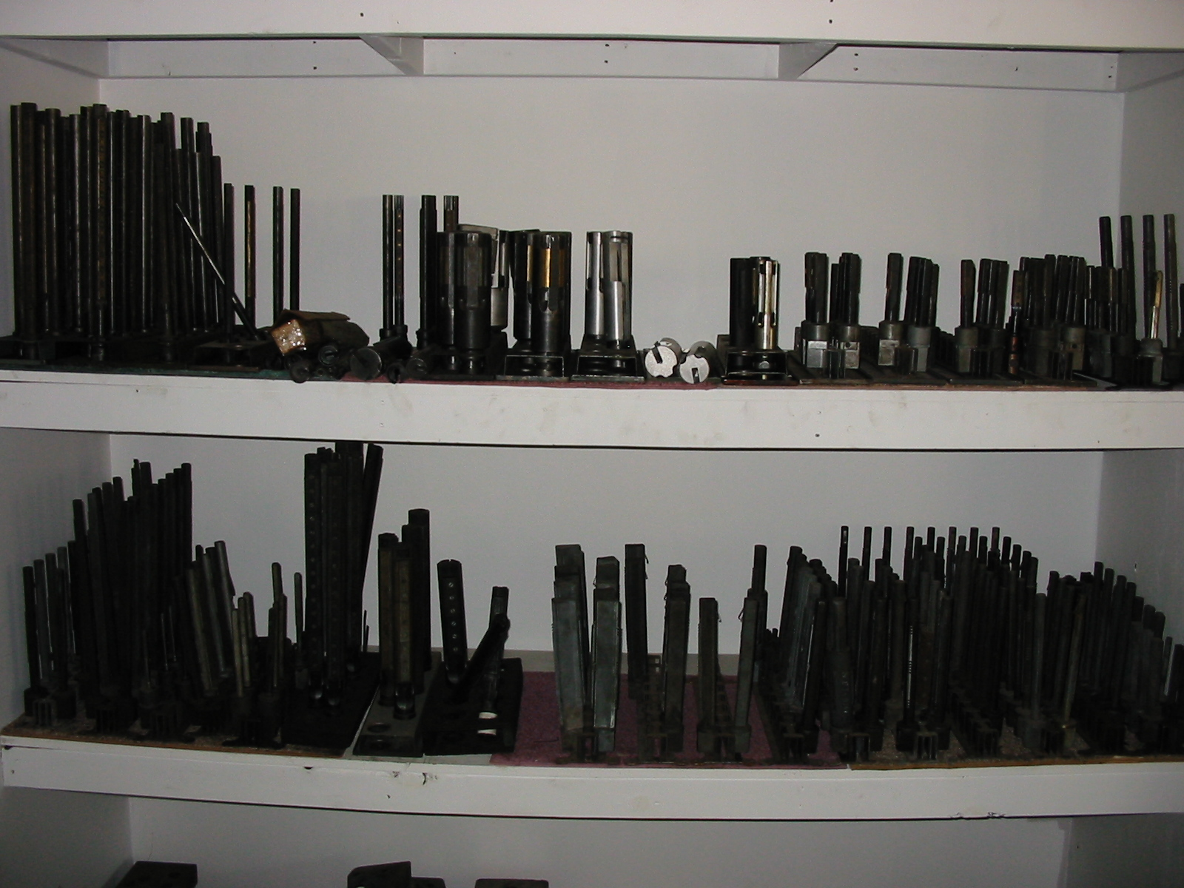

We Also Stock A Wide Variety Of Used & New Machine Parts & Tooling.
We Have A Large Selection Of New & Used Van Norman Boring Bar Parts.
Need A Sunnen Mandrel Give Us A Call.

We Have A Large Inventory Of Used Tooling & Hard To Find Machine Parts

Thank you from all of us at Cavco Sales

Dan, Cindy, Jeff, Cameron & Caleb

